Final Paper

**Future of retail: Will online take over the world?**

Yana Routshtein

GRAD 699-90: Late Spring

Instructor: Olga Scrivner

June, 2018

**Introduction**

Retail industry has been changing very rapidly over the course of the last decade. Customer preferences are changing dramatically as a result of the development of new technologies, increasing urbanization and changes in disposable income.

The industry is in transition, today’s market conditions drive rapid adaptation of innovation and reevaluation of traditional profit models or partnerships. New challenges are likely to arrive along with opportunities. Taking stock of what extended business ecosystems may offer in terms of procuring and leveraging consumer insights—and creating the acumen and agility to engage with consumers at a preferred touchpoint – may well offer retailers a competitive advantage. Consider focusing on strategic responses by recasting the value proposition and operating model to holistically address and deliver on the implicit as well as explicit desires of the customer. Take into account that these responses are often disruptive in nature and may require time to remodel how the customer’s influence should evolve within the scope of a retail ecosystem. Help ensure that strategic responses should strive to be customer-centric by potentially focusing on how the behavioral dynamics of diverse consumer segments may shift, rather than on how the customer interacts with the brand in question (Sides & Ament, 2018).

Technological advancements, shifting customer preferences along with ecomonic changes affect the shifts and developments across shopping channels. Online is growing exponentially making everyone believe that this is the only place to be if you want to secure your future in the game. New players and formats drive fragmentation of brick and mortar when online retailing, although seems to be new, fresh and emerging, is largely controlled by one dominant player. Giants of the past, like Macy’s, struggle to adapt to rapidly changing reality, losing market share to specialty stores and online players. Where the industry will be in 5 years from now? Who will be the winners?

**Questions and Hypotheses**

The noise around exponential growth of online poses a question - will online be the format of the future? Do people still need stores? Does one size fit all? Is online is the right channel across all retail formats? Answers to these questions will help retail players understand whether online is indeed the right investment for them, what mix of online and in-store is right for their business. Retail players chase the competitors trying to get better in online experience, distribution, innovate in delivery options but what if these investments will not yeild the desired outcome?

I would like to explore how e-commrece consumption has evolved and how different economic factors affect online and retail spend, which should help retailers with what indicators to look for once they plan their online and in-store sales.

This research is driven by practical implications of an ability to predict how the dollars will move between in-store and online. Understanding of this movement has a potential to inform better strategic planning for retailers. Should retailers close stores before it is too late? Should they consider Amazon a serious competitive threat (which is actually the case already across all retailers in an epidemical manner)? Should they expand the online presence? All these questions are on the priority list for most of the retailers and need answers and better understanding of the channel shifts. What if customers do not think of you as an online retailer? Many industry experts believe that one size does not fit all, and some formats, such as off-price retailers (e.g., T.J.Maxx, Marshalls), are not designed for online experience and succeed extremely well because of what they have to offer in their physical stores.

I believe along with other industry thought leaders that one size does not fit all. Each retailer format has its own optimal combination of online and in-store operations, which also can change as customer preferences evolve over time. Some retail types have a better fit for online, because the channel is catering to the same customer needs as the format. For instance, grocery stores these days put a lot of emphasis on convernience. New mini formats in large cities are a great example of that. Online as a channel has convenience in its core, therefore, buying groceries online is so easy and expanding so quickly. But there are formats where the opposite may be true. Going back to the example of off-price retailers, people visit such stores for a tresure hunt. They want to touch, to smell, to review multiple items in order to find the best fit and the great deal. This experience by its nature is very physical. Moreover, it is extremely hard for a retailer like that to keep track of the available inventory due to the fact that it sells items that are not necessarily organized by brand, collection, size or any other attribute. For this study I did not explore each of the formats separately, but picked a few in order to look specifically into categories that appeared to be popular for online shopping.

Majority of the analysis will be focused on the economic factors that drive retail and specifically online consumption. My hypothesis is that spend on services, Gross Domestic Product (GDP), Consumer Confidence Index as well as Price Index will serve as good indicators of the projected growth for e-commerce sales in the US.

If we are looking to understand what the future holds for us, the core driver of our focus should be the customer and what the customer will be looking for. Not much of the academic analysis was done in the field, but many consulting companies and industry experts conduct research to predict the near future of the industry, the literature review will discuss in detail the available work. These studies and thought leaders of the industry largely shaped my hypotheses and my understanding of different trends that are happening in the retail industry today.

**Literature Review**

**Industry perspective: ‘The Great Retail Bifurcation’**

Deloitte’s point of view on the industry is that retail is not going through apocalypsis as many think but expriencing a renessance. The authors review several market developments and trends and discuss how they affect the retail industry. The authors examined future oriented economic parameters: GDP growth, stock market growth, household net worth, household debt-servicing payments, and their conclusion is that all these have improved recently painting a better outlook for the industry. Retail spending is actually growing faster than GDP or other parameters. The authors specifically address the shift changes, pointing out that in the future there is still a place for brick and mortar (Lobaugh, 2018).

**67 fascinating facts about Ecommerce vs Brick and Mortar**

Rose Leadem in her article ’67 fascinating facts about Ecommerce vs Brick and Mortar’ for Entrepreneur.com brings up a few interesting facts that help understand the current state of things between the two formats and shifts in customer preferences. First, it is important to understand that although ecommerce is something that everyone is talking about, it is portion out of the retail sales in not proportional to the amount of noise it makes (~12% in the US for 2017). However, the projections are that it will grow at 15% year-over-year rate, whether the brick and mortar retailing is expected to grow only by 4.5% (both numbers with respect to the US market). With respect to people’s preferences, on average 51% Americans prefer to shop online and 49% prefer to head to the actual store. For millennials though this number is significantly higher, with 67% preferring to shop online (Leadem, 2018). Millennials are known as having great influence over their parents, the baby boomers, when it comes to new technologies as well as on their children, therefore, I would expect this ratio to change based on the adaption of ecommerce by other generations. Price sensitivity and convenience cater to larger populations and will be the main drivers behind the future of both channels. Another top reason for online shopping is the ability to do it any time, which becomes a necessity giving the intensity and mobility of today’s life.

**Customer’s role in retail channel shifts**

One of the most commonly used industry terms is ‘omni-channel’ which is basically another way to say multi channel. Consistent experience across different shopping channels is extremely important for consumers and for the retailers to maintain their brand perception. Leslie Ament in her article ‘Onmi-Channel Design: Is Your Business Ready?’ talks about the imporance of consistent omni-channel experiences and why organizations should pursue strategies that will cater to customer preferences across chanels. The simple answer is because customers demand it. To maintain customer loyalty and win new business along with greater share of customers’ wallets, consumer-facing businesses should consider these objectives: increasing “stickiness” by guiding consumers’ omnichannel journeys toward a path to purchase; attracting buyers to both physical and online stores with improved loyalty programs and experiential engagements; offering unique or highly differentiated product and service offerings while ensuring in-stock inventory levels; and achieving operational excellence in addressing customer service and support requests (Ament, 2017). Ament also writes about imporance of customer analytics as a mechanism for keeping up with changes in customer preferences, tracking and anticipating customer demand. According to her research, involving 565 global survey respondents, nearly 45 percent cited using customer analytics and insights to enhance profits by optimizing the customer journey. Other top benefits include the creation of forward-looking predictive insights for proactive customer engagement (57.6 percent) and the ability to create customer personas for more personalized engagement (50.5 percent). The businesses acknowledge the ability to design proactive, customized, in-moment journeys of engagement is now a top priority. Embedding analytical models within customer engagement workflows facilitates brand consistency and optimizes personalization through automation. It shortens time to value by designing customer journey and customer engagement programs. Ament proposes the following criteria for consumer-facing businesses to evaluate the relationship-building benefits:

First, adaptive interaction rules and artificial intelligence (AI) to optimize the customer experience according to channel preferences.

Second, predictive or prescriptive next-best action upselling, cross-selling, and trade promotions to highvalue customers who are most likely to purchase.

Third, data and contextual information prior to analysis in order to enhance customer engagement.

Forth, real-time customer engagement based upon various embedded analytical techniques such as, but not limited to, adaptive interaction, predictive next-best action, contextually aware interaction, automated behavioral targeting, or prescriptive guidance.

Finally, multiple customer information sources, including mobile, kiosk, point-of-sale (POS), web, CRM, ERP, supply chain, social channel, and third-party data.

I believe that there are two groups of drivers to consider for this research. One, largely described by Ament, is the customer preferances and how to perfect in anticipating them. The other side of the coin are the economic developments that define on a more high level how much people spend, how much they have to spend based on their economic situation and how they allocate their budget across different products and services that they need to consume in order to maintain their life. How much money people spend on retail is defined by how much they spend on health, educaction, leisure and other things that take pieces of their descritionary income.

**Economic factors impacting retail spend**

Based on the recent research conducted by Deloitte’s leading economist Ira Kalish (Deloitte, 2017b), there are a few trends that will define the close future of the retail industry.

First, customers identify themselves less with how many things they own and more in how curated their life experiences are, which can be labeled as intentional consumption.

Second, changing preferences following the economy – customers are seeking experiences and products that reflect the personal brand that they promote in social media - what people think about me online?

Third, the maker movement and the shared economy made it difficult to define what retailer does and what it is - retailization of the world.

Forth, relevancy will be determined by retailer’s ability to meet on-demand mindset of the modern customer - on demand shopping and fulfillment.

Finally, the use of artificial intelligence and augmented reality is expected to continue and scale in being a part of shopping experience – exponential living*.*

The economic environment for retailers continues to be challenging. It includes slow economic growth in major developed economies, high levels of debt in emerging countries, deflation or low inflation in rich countries, a protectionist backlash against globalization, troubled credit markets in some countries, and worsening demographics in many countries. And yet people still need to shop, so the industry carries on. Moreover, in some places and with some cohorts of shoppers, the outlook for retailers is favorable (Deloitte, 2017b).

The US economy continues to chug along at a modest pace. The labor market has tightened and likely reflects something close to full employment. That explains why wages have accelerated, especially at the lower end of the income scale. This has led to concerns that inflation could get out of hand lest the Federal Reserve steadily raise interest rates and slow the economy. On the other hand, with labor market participation historically low and with a recent deceleration in job growth, it is argued that the US economy is actually sputtering and is at risk of recession. Thus, this view suggests that the Federal Reserve should not tighten monetary policy too quickly. This view also supports a potential fiscal stimulus. Meanwhile, the main driver of US economic growth continues to be the consumer sector. This has been fueled by rising employment, accelerating wages, low energy prices, improved consumer finances, greater availability of consumer credit, and pent-up demand. These factors have also driven improvement in the housing market which, in turn, influences retail spending on home-related products (Deloitte, 2017b).

In 2018 Deloitte published an updated overlook of the global retail industry in Global Powers of Retailing 2018. This report is largely focused on the transformative time that the industry is going through, 4.0 industrial revolution did not pass by this industry. Retailers invest heavily in world class digital capabilities but not only digital is important for future success, retailers are combining brick and mortar to make up for the lost time.

The retailing world is not about to sit idly by and watch Amazon shoot up the retail ranks and steal market share. Many players that may have initially been on the sidelines, failing to keep up with digital trends, are now making up for lost time in a big way. A recent study finds that global grocery sales through e-commerce channels jumped 30 percent in the past year. Five countries leading the growth charge were China (+52%), South Korea (+41%), the UK (+8%), France (+7%), Japan and the US (both +5%). China is the world’s dominant ecommerce—and mobile—market (Deloitte, 2018a).

The world’s largest retailer, WalMart, has made it clear that ecommerce is one of the company’s strategic pillars. WalMart is pumping billions in capital investment to introduce Online Grocery, ramp up click-and-collect capabilities, and leverage its vast network of stores to marry online and offline assets and gain an edge over Amazon. The retail giant also has been on an acquisition spree of late, buying the likes of Jet.com, ShoeBuy, Moosejaw, ModCloth, and Bonobos to quickly attain ecommerce capabilities in lieu of building from the ground up (Deloitte, 2018a).

Physical retail stores are not going away; 90 percent of worldwide retail sales are still done in physical stores. But to compete with the convenience and endless aisle assortment offered online, meaningful customer experiences and brand engagement is crucial. Stores like Apple Store and Nike are extraordinary examples of excellence for the in-store experiences that retailers can offer, way superior to online (Deloitte, 2018a).

Other bricks-and-mortar retailers are realizing the importance of creating unique and curated merchandise offers, an exciting and entertaining atmosphere, and concierge-like service levels beyond what consumers can find online. What is starting to happen inside grocery stores across the globe is a good example (Deloitte, 2018a).

Grocers are transitioning from providers of goods to purveyors of services and solutions, with food, health, and wellness converging in a retail setting. A host of retailers already have added in-store health clinics and on-site nutritionists and dieticians. US supermarket chain Hy-Vee is now teaming with OrangeTheory fitness centers to open locations in some stores and integrate training and nutrition services. In the UK, Debenhams is trialing fitness centers in collaboration with gym specialist (Deloitte, 2018a).

**Retail formats**

These findings suggest that there is enough room for both online and in-store. But we need to understand the developments in each of the dominant retail formats in order to start driving conclusions on the optimal mix for different formats. Department stores is one of the major formats that got affected by the growth of online.

IBIS report of Department Stores indicates that the overall the format is not growing, revenues have been volatile, with players like Macy’s declining and mass merchants like Walmart and Target protecting their share. One trend is clear – online share is growing exponentially. Ecommerce stores benefit from lower overhead costs than brick-and-mortar stores. As a result, online retailers can offer lower prices, wider inventories and the ease of direct shipping. An increase in the percentage of services conducted online will likely decrease demand for traditional brick-and-mortar stores. Cohen believes that the percentage of services conducted online is expected to continue rising, representing a threat to department stores (Cohen, 2017).

Online retailers can offer customers perks, like free shipping, that physical stores cannot. Specialty stores are taking the share from the department stores. According IBIS World report on the specialty stores in the US, this retail format is growing exponentially with especially strong increase in online (Cohen, 2017).

**Brick-and-Mortar vs. Ecommerce Stores: How to Leverage the Best of Both**

Kuczwaraz talks about the complexity in the relationship between brick and mortar and online, emphasizing that most of the studies talk about one or two statistics not understanding the dependencies based on various consumer considerations. What makes a consumer choose to shop in a physical store? A survey by Retail Dive asked more than 1,400 consumers that question (Skrovan, 2018). It found the answer depended on age, gender and even location. Regardless of demographic, the biggest reason cited by those surveyed was the ability to see, feel and try out the item they were looking to purchase. For women, this is the No. 1 driving factor for in-store shopping, especially for fashion items. Interestingly, this is also a significant driver for people over 65 and members of the millennial generation. Another driver for shopping at a physical location is immediate gratification. For men, in particular, the ability to take an item home that day inspires them to venture out to make a purchase. The least important element for most groups is getting help from a store associate. Having a person available to help isn't a significant draw to shop in a brick-and-mortar store. As for drivers on online shopping, Kuczwaraz refers to convenience of shopping anytime and everywhere first. ‘Being able to shop anytime, anywhere is a significant motivator that pushes more than $294 billion in annual online sales. With this number expected to increase to $414 billion by 2018, the ability to shop at midnight or in your sweats is an important consideration for many shoppers (Kuczwara, 2018).

There is a place in the middle where modern consumers use both brick-and-mortar stores and ecommerce to reach their goals. Research is one of the largest crossovers between channels. For online retailers, this means that some of their visitors use their website to read reviews, compare prices and understand features of products they are looking to buy. This accounts for some of the $4 trillion worth of merchandise abandoned in online shopping carts in 2014 alone (Kuczwara, 2018).

**Holiday spending**

Holiday season is the hottest time of the year that defines the annual performance results for most of the retailers, analysis of the 5 recent reports on holiday performance will help identify trends and build predictions for next holiday seasons (Deloitte, 2017a).

Preliminary findings indicate that the holiday spend is recovering with increasing online sales, Cyber Monday is bigger than Black Friday and Amazon is the ultimate winner.

This holiday overlook predicts that non-gift spending is expected to account for almost two-thirds (65 percent) of the average holiday budget this year, people expect to spend on personal items and they intend to spend more as their financial situation is improving (only 19% indicated that their financial situation got worse). Survey respondents indicated that they largely turn to online retailers due to the ease of finding the product that they are looking for, high quality of products and large variery. All these parameters scored less for the in-store shopping experiences. On average, 51% of spend is intended to be online, with millenials and Gen Z largely driving the shift of dollars to online. With that the reasons that drive people to a store are different, the majority of in-store shoppers wants to experience the product, avoid shipping costs and get ideas and inspiration for gifts. Based on the responses of thie holiday survey there is a place for stores to exist in order to experience and connect with products in a different way from what online can offer (Deloitte, 2017a).

**2018 retail, wholesale and distribution outlook: An industry in transition**

Deloitte’s overlook on retail, wholesales and distribution industryoutlines the main transitions happening in the industry and predictions on what to expect in 2018. By staying focused on customer demands (that are changing by segment or situation), tracking them through the right analytics and improving operations to deliver customer needs the retailers will succeed. More importantly for the topic of retail stores, Deloitte’s outlook states that retail stores will not disappear but there is a room for reconstruction of the stores and the experiences they deliver. Formats like’store within store’ and innovation in human resources with integration of smart technologies and robotics will drive change in how stores operate as well as how they are percieved by the consumers. For many retailers dual presence of in store and online will be important. However, retailers should realize that developing agility, along with an unparalleled ability to understand and target their unique consumers in a highly mixed channel environment may require change (Sides & Ament, 2018).

Movement of revenues among different formats reflects the shifts in customer preferences. Overlook on the performance of the specialty stores and market share shifts with the departmnet stores tells an interesting story to industry observers. Unlike department stores that are experiencing decrease for the 5th consecutive year, specialty stores in the US are growing at 2.5% per year, which is in line with the overall growth of the economy. This indsutry is known to be successful in catering to specific needs of the customer, players in specialty are usually successful in creating the emotional connection that larger retailers lack. However, the author believes that the industry is under severe chance of decline due to increasing competitive pressure from the large players like Whole Foods and online retailers, that leverage significant economies of scale. Online players cater to the convenience that becomes increasingly important for consumers, specialty stores cater to customers who are concerned about food safety and sourcing, the outcome of the battle between these two retailer formats will depend on which parameter will be more important to the consumer (Guattery, 2017).

**Shopping around : Preference for department stores and e-commerce will hamper growth Small Specialty Retail Stores in the US About this Industry**

Report on the small specialty retail stores tells similar story to the specialty stores, emphasizing the role of the larger players as a one stop for consumers where they can buy all they need. Larger competitors are taking market share due to their ability to lower pricing. Due to its fragmented nature, the industry is not driven by product specific trends but rather by broad macroeconomic variables. However, individual segments do respond to specific shifts in consumer preferences. Over the five years to 2017, rising income and employment have boosted demand throughout the retail sector. Despite this, small specialty stores are facing increasing competition from ecommerce and department stores, limiting gains from increased consumer spending. Consequently, IBIS World expects industry revenue to decrease at an annualized rate of 0.4% to $31.4 billion over the five years to 2017. Revenue is expected to decline 0.3% in 2017, as e-commerce sales improve and consumer confidence wanes due to prolonged slow growth and uncertainty. Discount department stores and online retailers have increasingly taken retail market share from the industry with one-stop shopping and lower prices for similar product. Despite moderate revenue declines, the number of enterprises in this industry is marginally increasing. Small companies are able to start up with low capital input, and they are increasingly attempting to generate higher margins on more premium items. Over five years to 2022, this industry is forecast to continue its marginal decline. IBISWorld forecasts growth in consumer spending, while consumer confidence is expected to decrease. Consequently, increasing levels of discretionary spending focus on price over specialty. E-commerce retailers often offer substitute industry products at heavily discounted prices. In addition, specialty items, such as rare cigars and collectibles, are sometimes easier to find and purchase online. Therefore, as more consumers visit online retailers for their shopping needs, demand for brick-and-mortar establishments will fall. Ecommerce sales are expected to increase, posing a potential threat to the industry (Miles, 2017).

**The Global Powers of Retailing 2018**

The Global Powers of Retailing for 2018 is focused on the transformative change that the industry is going through. Customers shop everywhere, any time and by using any means they want, not only mobile devices by voice recognition and other technologies that change the experience and the way people buy things. Digital interactions effect 56 cents on each dollar spend in retail globally. The rules of retailing indeed are being rewritten in this time of transformative change. Innovation, collaboration, consolidation, integration, and automation will be required to reinvigorate commerce, profoundly impacting the way retailers do business now, and in the future. Retailers across the globe are rapidly adapting to the fact that, from the consumer perspective, shopping is not about bricks versus clicks or one channel versus another. Instead, consumers are channel-agnostic. The shopping journey and pre-shopping research is a fluid process with consumers bouncing between online and offline along the path to purchase. This means retailers must adequately and holistically plan, strategize, and execute across all channels, regardless of whether the ultimate sale happens in-store or online. A seamless shopping experience is no longer a nice to have, but an imperative. And it is a key reason why retailers worldwide are heavily investing in online and digital. More than ever, the retail industry is rife with examples of companies building, buying, or partnering to attain much-needed e-commerce and last-mile capabilities. Amazon is bigger and more powerful than ever. It continues to enter new markets, expand product categories, and test new technologies and concepts, leaving a path of disruption in its wake (Deloitte, 2018a).

**Retail 360: Connected Stores**

Not only the question of brick and mortar vs online is important here but also, how the future brick and mortar will look? ‘Retail 360: Connected Stores’ report summarizes Deloitte Digital’s research in transformation of a retail store as well as the results of the Lab that the team created in Belgrade, Serbia, where they installed the technologies in a retail store, creating the store of the future. The authors argue that in 2017 the re-birth of the retail store started, rather than the disappearance. Stores have become the focal point for traditional retailers once again. Former online pure-players like Amazon.com and Alibaba have started opening brick and mortar stores to provide the full experience oﬄine that customers expect online. Pure-players have traditionally run their business online, where everything is measurable and where data drives their decisions. When opening brick and mortar stores, pure-players have kept this data-driven mentality and designed their brick and mortar stores accordingly. Most of these stores are equipped with technology that enables them to collect data from their customers and use this data to make educated decisions. Retailers should think about the unique characteristics of online and offline channels instead and try to optimise them accordingly. Appreciating the entire ecosystem of touchpoints will help retailers improve each channel and deliver a more powerful and holistic customer experience (Deloitte, 2018b).

**Global Powers of Luxury Retailing 2018**

Luxury goods are not different from other products when it comes to rapid adoption of ecommerce. Deloitte’s Global Powers of Luxury Retailing report looks into the performance of top 100 luxury brands globally and demonstrates that although the sector in total grown only by 1% year over year, the online for most of the leading brands moved forward with double digits, for some brands even as high as above 80% (Arienti, 2018). This means that for luxury goods, online is taking over brick and mortar much faster than for other sectors. The experience of walking in to the luxury store and being served loses its power over convenience, accessibility, larger assortment and ability to complete your purchase almost instantly.

For much of the past decade, luxury fashion brands have struck a sensible balance between exclusivity and accessibility resulting in strong financial results. They were slow to adopt digital media to grow sales, fearing they might become too visible. However, as luxury consumers began spending more online, brands were left with no choice but to adapt to their customers’ new purchasing patterns. With so much availability, mass reach and lower prices, brands are now concerned they may be compromising their exclusivity. Luxury brands have begun to focus on changing their portfolio structure to increase scarcity, helping maintain their aura of prestige. Examples of strategies adopted by luxury fashion brands include reducing the number of entry level products, physically distancing off-price outlets from city center stores and re-orienting perceptions to emphasize higher-priced, iconic products with more subtle brand signifiers (Arienti, 2018).

**Tech Trends**

Development of technology played a major role in adoption of ecommerce over brick and mortar. Many things became possible with augmented and digital reality and advanced analytics. Today, a retailer can take a shopper on a trip at its store without having him leave the house, supplying the most personalized experience that can be developed through digital reality. This is why I decided to include this study in my research because the technology trends very much defined how the retail industry looks today, how the omni-channel experience works for customers and why there are movements between brick and mortar.

Over the next decade, advances in digital reality—an amalgamation of augmented reality (AR), virtual reality (VR), mixed reality, 360°, and immersive technologies—will lead to more natural and intuitive ways for technology to better our lives. Indeed, our means of interfacing with digital information will likely no longer be screens and hardware but gestures, emotions, and gazes. This represents a leap forward comparable to historic transitions from client-server to the web, and web to mobile. And it may already be under way. What accounts for such explosive growth? Increasingly, companies are shifting their focus from experimenting with “shiny object” AR and VR devices to building mission-critical applications in the enterprise. Consumer-oriented investments in gaming and entertainment continue, but increasingly the real action is happening in the workplace. It is estimated that industry AR/VR use cases that will attract the largest investments are onsite assembly and safety ($339 million), retail showcasing ($250 million), and process manufacturing training ($248 million) (Margolies et al., 2018). With integration of digital reality, I expect that retailers will be able enhance their online experience, accelerating the growth of online over brick and mortar. Digital reality has the potential not only replace the physical store or completely replicating it, but also take the customer to any life situation they need as they are on the journey. The example of it would be the demonstrative technology that Deloitte developed for 2018 Shop Talk conference in Los Angeles. Through digital reality headset one could evaluate how the camping equipment that she was going to buy would fit the view in a national park she was going to visit, how the dimensions would fit and where the things could be placed and used. This kind of technology can be applied across any format and sector, significantly accelerating the decision-making process for customers.

**Methodology**

There are multiple factors and variables that affect online shopping. In my opinion, the question should be examined from two perspectives: economic factors affecting spend on goods and how they affect the e-commerce, and customer consumption that can help dive deep into how it changed as ecommerce was evolving. Therefore, I separate my analysis into 2 distinctive pieces that use different datasets to show two different perspectives on the question.

I will be using regression and correlation analysis as well as cluster analysis to combine and separate factors of influence on the online shopping to be able to segregate the most vital ones.

**Analysis**

**Part I: Economic factors that affect ecommerce spend in the US**

For the purposes of understanding how the e-commerce spend is affected by economic factors I compiled a dataset that contains the following numbers:

First, US Retail and E-commerce sales, retrieved from the Retail Indicators Branch of U.S. Census Bureau (US Census, 2018).

Second, US Price Indexes for Personal Consumption Expenditures retrieved from Bureau of Economic Analysis, and Federal Reserve Bank, St Louis. The price index on goods and services used for personal consumption is expected to be an important factor in people’s ability to spend, both on retail goods overall and ecommerce specifically (Federal Bank of St. Luis, 2018).

Third, US Gross Domestic Product (GDP) retrieved from the Bureau of Economic Analysis in the Chamber of Commerce. GDP is a common measure of economic health that expected to be correlated with spend on retail goods and services ( Mataloni, 2018).

Forth, Consumer Confidence Index retrieved from OECD Data (OECD Data, 2018). Due to the lack of an isolated figure for the US (available for free), I used the G-7 consumer index, implying that due to globalization processes and availability of goods at the global level, consumer confidence index will not differ much among developed economies comprising the G-7. This has the limitations as certain products may vary depending on the components of the local economies for each one of the G-7 members.

All figures used the most updated, even for the historic figures, the most recent releases were obtained. The data represents the figures on quarterly basis and looks back to the period starting at Q1 of 2013 through Q1 of 2018.

In order to start exploring let’s first look into the magnitude of the issue in question. Everyone is talking about how significant ecommerce growth has been but not many know that de facto the portion of online sales as part of the total retail sales in the use is somewhere about 10%. Figure 1 illustrates how online sales in the US has been evolving over the course of the last few years.

Figure 1: Retail and E-commerce Sales in the US (US Census, 2018)

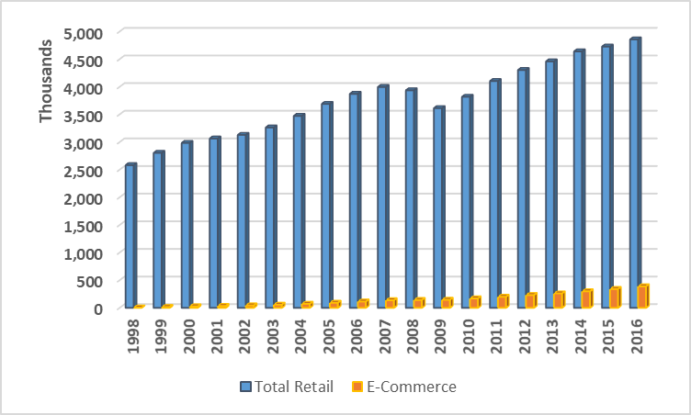

According to US Census, total retail sales in the US reached 5,075 billion in 2017, while online portion of it is about $453 billion, representing 8.9% (US Census, 2018). If anything, the ecommerce has a long way to go until it will be able to take over the brick and mortar, but it is important to remember that it is growing in a much higher pace (32% on average for the last 20 years, based on the numbers in Figure 1) than the overall retail industry (3.6% on average using the same numbers).

In order to understand the economic factors affect retail and ecommerce and if these are different I applied regression analysis examining different combinations of the chosen parameters.

The initial analysis of all independent variables as predictors of ecommerce sales did not show that any of the variables have significant influence over the ecommerce sales. Based on the R Square the model described 91% of the observations, demonstrating sufficient level. See the regression output below, on Figure 3.

Figure 3: Regression output for ecommerce sales as a dependent variable and Real GDP, spend on goods, spend on services, consumer confidence and price indexes as independent.





It is a common wisdom that these parameters indeed have influence over one’s ability to spend. Therefore, as a next step I explored whether regression of the total retail sales would return similar results, and indeed it returned similar results with slightly different variation of R Square, meaning describing less of the retail sales observed than ecommerce sales. No one of the p-values is lower than 0.05 indicating that no one of these economic parameters is a good predictor of retail sales.

Figure 4: Regression output for total retail sales as a dependent variable and Real GDP, spend on goods, spend on services, consumer confidence and price indexes as independent.

|  |  |
| --- | --- |
| ***Regression Statistics*** | |
| Multiple R | 0.8570211 |
| R Square | 0.7344852 |
| Adjusted R Square | 0.6459802 |
| Standard Error | 54854.536 |
| Observations | 21 |



However, we have to remember that many of the parameters explored in on this list of independent variables can be correlated with each other, resulting in similar results across all of them. Therefore, I decided to perform correlation analysis to look into variables that might be correlated with each other.

Correlation analysis returned the following results:

First, spend on goods and services is almost perfectly correlated with each other, which is although logical, giving that people spend on both more when they have more money, but somehow unexpected, as I would assume that these two will take share one from another.

Second, Price Index for Personal Consumption Expenditures is correlated with Consumer Confidence Index. The conclusion of this observation would be that when people feel more confident about the future, they tend to spend more, which drives price increases as the market senses high demand for goods and services.

Figure 5: Correlation results for independent variables

|  |  |  |
| --- | --- | --- |
|  | ***Goods Spend (in Billions)*** | ***Services Spend (in Billions)*** |
| Goods Spend (in Billions) | 1 |  |
| Services Spend (in Billions) | **0.970034533** | 1 |

|  |  |  |
| --- | --- | --- |
|  | ***Price Index(Personal Exp)*** | ***Consumer Confidence Index*** |
| Price Index(Personal Exp) | 1 |  |
| Consumer Confidence Index | **0.881173864** | 1 |

To further explore the relationship of ecommerce sales and Price Index for Personal Expenditure as well as Consumer Confidence Index I applied regression analysis using only these two independent variables. I expect them to be the strongest predictors out of all other independent variables. Figure 6 expands ton he details of the result.

Figure 6: Regression analysis of e-commerce sales as a function of Price Index and Consumer Confidence Index

|  |  |
| --- | --- |
| ***Regression Statistics*** |  |
| Multiple R | 0.7830108 |
| R Square | 0.6131059 |
| Adjusted R Square | 0.5701176 |
| Standard Error | 60446.842 |
| Observations | 21 |



Based on the p-value of both, Consumer Confidence Index and the Price Index, we clearly see that no one of them appear to be a good predictor of the online sales. It means that neither price increases nor confidence about the future appear to be good predictors of the online sales. Although we do need to admit that based on the R Square only 61% of observations appear to fall into this description.

Anova analysis confirmed the significance of this conclusion. See Figure 7 for the results of Anova.

Figure 7: Anova analysis for significance of the regression analysis for e-commerce sales

|  |  |  |  |  |  |
| --- | --- | --- | --- | --- | --- |
|  |  |  |  |  |  |
|  | *df* | *SS* | *MS* | *F* | *Significance F* |
| Regression | 2 | 1.04223E+11 | 52111435625 | 14.262 | 0.0001942 |
| Residual | 18 | 65768772343 | 3653820686 |  |  |
| Total | 20 | 1.69992E+11 |  |  |  |

This conclusion does seem intuitive. One would expect that when the prices are higher, the total sales will be affected, either by growing if the economy is well, or by drop in volume caused by a drop in demand. Indeed, the regression analysis for the total retail sales returned a different result. See Figure 8 for details.

Figure 8: Regression of total retail sales as a dependent of Price Index and Consumer Confidence Index

|  |  |
| --- | --- |
| ***Regression Statistics*** |  |
| Multiple R | 0.7830108 |
| R Square | 0.6131059 |
| Adjusted R Square | 0.5701176 |
| Standard Error | 60446.842 |
| Observations | 21 |



Based on the analysis of the entire universe of retail sales in the US for the last 5 years, Price Index is the one that has influence over the amount of total sales. Meaning, every increase in the Price Index corresponds to $30,304 million in total sales. Giving that the economy has been growing over the course of the last 5 years (largely driven by increasing customer spend), this conclusion seems reasonable. The Anova analysis confirmed the significance of findings.

Figure 9: Anova analysis – total sales as a function of Price Index and Consumer Confidence

|  |  |  |  |  |  |  |
| --- | --- | --- | --- | --- | --- | --- |
|  | | *df* | *SS* | *MS* | *F* | *Significance F* |
| Regression | 2 | | 1.04223E+11 | 52111435625 | 14.262177 | 0.000194236 |
| Residual | 18 | | 65768772343 | 3653820686 |  |  |
| Total | 20 | | 1.69992E+11 |  |  |  |

In conclusion, by comparing the findings between total retail sales and online sales, we can clearly see that online sales are less affected by price increases than total sales. Online retailers appeal to a different customer need – convenience. People are willing to pay more for convenience and are less price-sensitive when it comes to online orders. One of the confidential studies that I happened to do for one of my clients indicated similar results, helping quantify how much people actually willing to pay for convenience per different types of products. The higher value of the product the higher would be the difference a person will be willing to pay to get it in a more convenient way.

The next question that I would like to explore is whether spend on goods is different from the spend on services. My hypothesis is that these two components of customer spend will be driven by different motivations and I would like to look on them again through the lens of Customer Confidence Index and Price Index. See below the results for Spend on Goods as a regression of Customer Confidence Index and Price Index.

Figure 10: Spend on Goods as a regression of Customer Confidence Index and Price Index

|  |  |
| --- | --- |
| *Regression Statistics* | |
| Multiple R | 0.994170293 |
| R Square | 0.988374572 |
| Adjusted R Square | 0.987082858 |
| Standard Error | 20.45683761 |
| Observations | 21 |



Based on the output we can clearly see that Price Index is a predictor of Sales of Goods, explaining as high as almost 99% of observations. Anova analysis confirms the significance of findings.

Figure 11: Anova analysis for regression of Spend on Goods vs Customer Confidence Index and Price Index

|  |  |  |  |  |  |
| --- | --- | --- | --- | --- | --- |
|  | *df* | *SS* | *MS* | *F* | *Significance F* |
| Regression | 2 | 640415.8984 | 320207.9492 | 765.1650308 | 3.87865E-18 |
| Residual | 18 | 7532.679688 | 418.4822049 |  |  |
| Total | 20 | 647948.5781 |  |  |  |

Exploring the Services demonstrated different results, showing that Consumer Confidence Index is actually a good predictor of spend on services. It means that when people feel confident about their future they tend to spend more. See details on the analysis on Figure 12.

Over the course of the last few years, we have been observing not proportional increase in spend on services, taking over the spend on goods. For instance, using the same data set (Q1’13-Q1’18) the average growth of spend on goods quarter over quarter is 0.7%, when for services the average growth is 1.2% which is 1.6 times as high as on goods. I believe that this trend is driven by two main groups of customers: millennials who are seeking experiences over goods, and baby boomers and their children who spend more on services to support their lives and provide convenience to aging population.

Figure 12: Spend on Services vs Price Index and Consumer Confidence Index

|  |  |
| --- | --- |
| ***Regression Statistics*** |  |
| Multiple R | 0.985391065 |
| R Square | 0.97099555 |
| Adjusted R Square | 0.967772834 |
| Standard Error | 109.5968138 |
| Observations | 21 |



Figure 13: Anova test for Spend on Services vs Price Index and Consumer Confidence Index

|  |  |  |  |  |  |
| --- | --- | --- | --- | --- | --- |
|  | *df* | *SS* | *MS* | *F* | *Significance F* |
| Regression | 2 | 7238039.88 | 3619019.9 | 301.29722 | 1.453E-14 |
| Residual | 18 | 216206.309 | 12011.462 |  |  |
| Total | 20 | 7454246.19 |  |  |  |

Based on p-values Price Index plays role when it comes to spend on services, but coefficient indicates slightly lower impact, meaning that consumer confidence is a more powerful driver of the customer spend on services than Price Index. One of my personal beliefs is that the nature of spending on services dictates this difference. Spend on services requires more planning than spend on goods. Whether I am planning a summer vacation or my retirement, I still think ahead. How much I will spend planning my future experience or service (hotel, guided tours, tickets to shows, etc.) depends on how confident I am in my future ability to pay for these services. Therefore, the Consumer Confidence Index plays a bigger role when it comes to services than when it comes to goods.

Now when we got some clarity on the economic drivers of the retail spend I would like to discuss the second piece of my analysis that looks into how consumer spend has evolved over time.

**Part II: Customer consumption of online goods**

For the purposes of demonstrating how consumption evolved from the customer perspective I used a transnational data set which contains all the transactions occurring between 01/12/2010 and 09/12/2011 for a UK-based and registered non-store online retail. The company mainly sells unique all-occasion gifts. The choice of using a niche company is not accidental. I would like to explore whether this format moves in line with the overall retail market. This will help me understand whether ‘one size fits all’. The limitation of this dataset is that it demonstrates only one retailer rather than all sellers in this niche market that is also higher affected by seasonality. However, the data set is one of the most comprehensive available for free use and contains 541,910 individual transactions for the period of 12 months.

Data set structure

Columns:

1. InvoiceNo – invoice number.
2. Stockcode – item code that was purchased in the transaction.
3. Description – item description.
4. Quantity – the amount of items purchases.
5. InvoiceDate – date and time of transaction.
6. Unit Price – price of the unit sold in transaction. Most of the transactions include similar unit numbers.
7. CustomerID – identification number associated with each unique customer.
8. Country – country of transaction, vast majority is in UK with few transaction in France in December 2011.

For the purposes of calculations to observe month to month growth, I projected the sales for December 2011 by multiplying the total sales for the first nine days of the month that we provided in the dataset by 31 and dividing by 9. This calculation assumes that daily sales for the second half of the month are comparable to the daily sales at any other day in the beginning of the month.

Figure 13: Month Over Month Sales Growth of an online retailer selling gifts

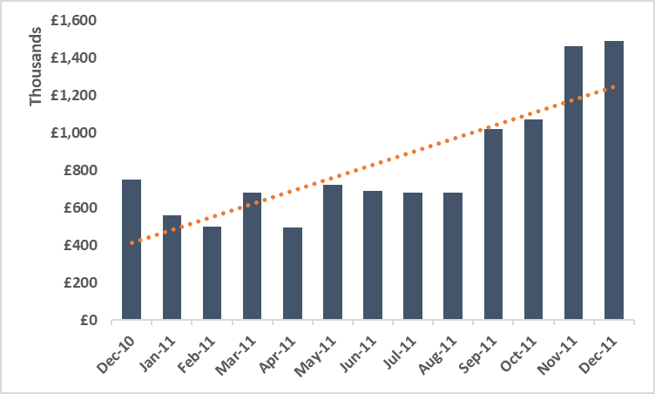

The slope of the trendline for this retailer does not indicate that sharp of a growth, in fact, it is only 9%, when the overall ecommerce sales growth in UK in 2011 equals 14% (Chen, 2012). This demonstrates that this niche market performs differently from online retail market in UK.

Now let’s explore whether customer behavior has changed in terms of transactional value. Figure 14 displays the average value per transaction for each month. It is quite obvious even visually that the value per transaction has barely changed over the course of these 12 months.

Figure 14: Average Spend Per Transaction Per Month

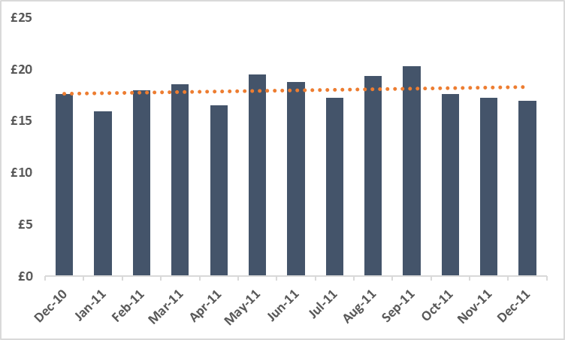

Lack of growth on the size of the transaction indicates that the amount of transactions has increased over the course of these 12 months. The question remains whether these came from the same customers or the retailer was able to grow its customer base over time. The growth of the customer based would indicate positive perspectives for the online channel. Figure 15 shows the number of customers who made transactions with the retailer. Although there is not much consistency, the clear trajectory of growth is observed. The growth in number of customers has increased by 1.1% month over month on average.

Figure 15: Number of customers who made transactions per month

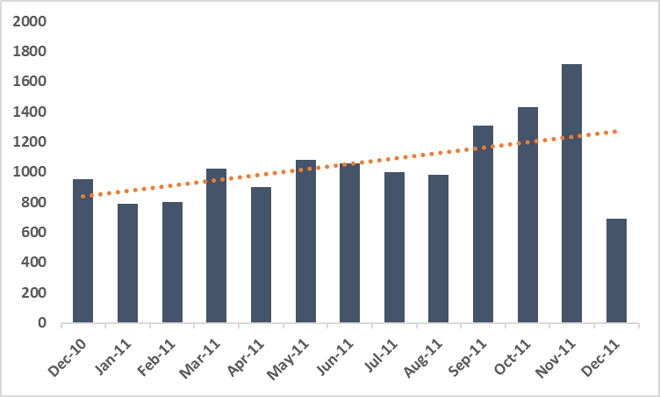

One limitation to keep in mind is that not all customers in the data set were identified, so there is a certain percent of missing at each and every month. If the total sales grew by 9% and the amount of customers grew only y 1%, it is clear that the customer engagement has increased. Unfortunately, we do not know due to what factors, but I believe that it will be fair to conclude that these factors are specific to this retailer, and we cannot necessary conclude that online for gift shopping attracts increasing number of shoppers.

This example of a niche industry helps to emphasize that online channel is not necessarily the best fit for each format. For this specific format the growth of online was slower than for the entire ecommerce and people did not tend to increase their spend because of online, which demonstrates highly transactional nature of this channel.

There are alternative ways to evaluate differences in shopping behaviors online between different categories or retail formats. Popularity of different categories on Amazon serves as an interesting indicator of how people shop different products online. Amazon currently represents 44% of all US sales online (Sun & Fool, 2018), providing a pretty good estimate as for what sells online and what not. Its top-selling category for 2017 was Consumer Electronics, followed by Home and Kitchen and Publishing. To me it indicates that people are more likely to shop things online that they can return easily (yes, it might be a bit of a large size, but it is not underwear that you cannot ship back), customers do not need to try, and it is not perishable.

Thinking about how different categories perform with respect to the overall retail growth, I conducted cluster analysis looking specifically into the categories that correspond to those that appeared to be extremely successful on Amazon.com last year.

Figure 16: Output of Cluster Analysis of Sales per Month per Product Category (nationally across US)

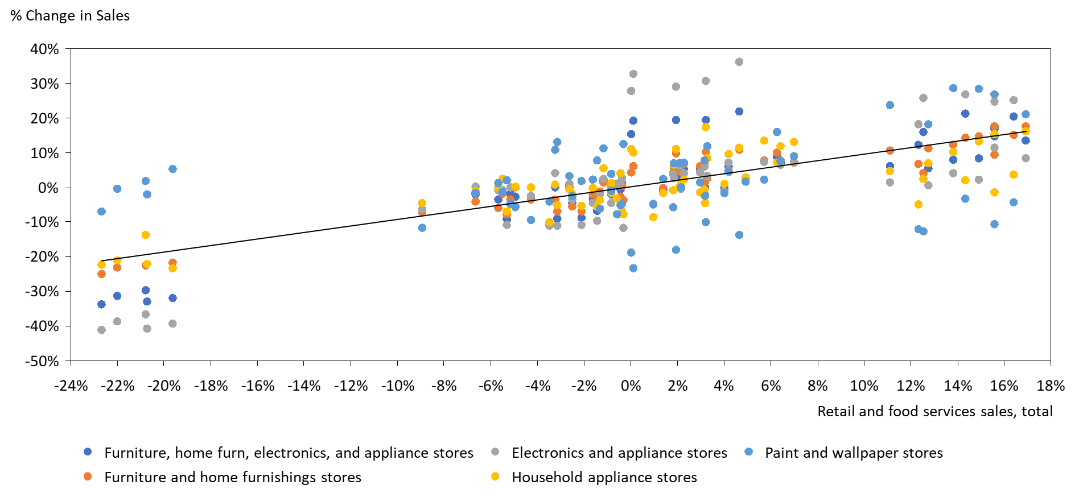

For furniture, home, electronics and appliance stores that change in sales is much more dramatic that for overall retail sales. We can conclude that the category is moving in the same direction as the industry overall, but ultimately it affected much more. For instance, in a quarter when the overall industry grew just by 2%, the furniture, home, electronics and appliance spiked by above 20%. Same dramatic change appears on a negative side as well. This helps us understand why the furniture and home category sales have been doing so great recently. The economy has been growing, the overall retail grew by ~9% but furniture would be expected to at least double this growth. This conclusion seems intuitive giving the nature of the furniture shopping. When the economy is doing well, people spend money on things that are beyond the essentials that support their day to day living, furniture is one of them. When the economy is not doing well, the first thing people cut is the things that are not essential for their daily survival.

Interestingly, home appliance stores appear to have a slightly negative correlation with the overall retail sales. It appears that there are many yellow and grey dots below the trend line that indicates the overall trend for retail. Meaning that when retail overall sells more, the appliances stores sell less. This is an interesting observation that can explain the increase in sales for Amazon. The sales for the category are not decreasing, they are switching channel, moving from the specialty stores to the online giant.

Essentially each category behaves differently and requires a closer look, but based on what I see for the furniture and the household appliance; both categories should explore hedging options for the times when the economy will not be great, as they have higher chances to be hit more than others.

**Conclusion**

The future of online retail is bright. There are growth indications in almost every category; there is a big market to capture ahead. Whether people will completely give up on stores is an open question that will require a different type of analysis that should explore customer desires and pain points of in-store vs online experience. There are several conclusions that we can drive from this research that will be beneficial in projecting where the industry is going. Customer Confidence Index as well as Price Index for Personal Expenditures serve as fair predictors of the change in the retail spend. It is important to differentiate between goods and services due to the nature of their consumptions and with understanding that they might cannibalize each other (with strong expectation that in the current economy the services will cannibalize goods).

With understanding of economic factors that affect retail, one size does not fit all. Not all formats and categories are successful online. In order to explore more concrete recommendations for what retail formats would have a better fit for online I recommend conducting a comprehensive customer study in order to learn about how customers shop each category within each retail format.

It is important to remember that in the consumer eyes in-store and online are one experience. Customers today are used to omni-channel integrations, expecting from the retailers and the brands they sell to deliver consistent experience across channels. This is critical when cross-channel influence happens. When I am browsing retailer website in a store searching for coupons on the product that I am about to buy, it is not clear which channel drives my purchase decision. Deloitte’s Digital Divide study conducted a customer study to evaluate what amount of in store sales are affected by digital interaction. According to this study 67% of people use digital to learn about customer reviews on their way to a store to buy the product (Simpson, Ohri, & Lobaugh, 2016). The percentage of in-store retail sales influenced by the shopper’s use of any digital device, including: desktop computers, laptops, netbooks, tablets, smartphones, wearable devices, and in-store devices (for instance, kiosk or mobile payment device) is increasing exponentially. It is an accelerating phenomenon that is both shaping how consumers shop and make decisions in-store and setting new, higher expectations for retailers’ digital offerings (Simpson et al., 2016)

This research is an attempt to get a bit more clarity on the future of the industry and how economic factors are shaping it. I believe that the next thing to watch is how the spend will be evolving between goods and services and how retailers should adapt in chasing not only online goods suppliers like Amazon, but also online service providers, like Airbnb or Expedia.

**References**

Ament, L. (2017). Omnichannel Journey Design — Is Your Business Ready ? *DestinationCRM.Com*, 1–3.

Arienti, P. (2018). Global Powers of Luxury Goods 2018 Shaping the future of the luxury industry. *Deloitte University Press*.

Cohen, A. (2017). Off the rack : Continued online retail growth is Department Stores in the US About this Industry, (June), 1–41.

Deloitte. (2017a). 2017 Deloitte Holiday Survey Results Summary. *Deloitte Holiday Survey*.

Deloitte. (2017b). Global Powers of Retailing 2017: The art and science of customers. *Deloitte*, 1–41.

Deloitte. (2018a). Global Powers of Retailing 2018 Transformative change, reinvigorated commerce. *Deloitte University Press*, 19–24.

Deloitte. (2018b). Retail360 / Connected Stores.

Guattery, M. (2017). Getting full : Despite favorable consumer preference trends , growth will decelerate Specialty Food Stores in the US About this Industry, (August), 1–33.

Kasey Lobaugh, Christina Bieniek, B. S. (2018). The great retail bifurcation Why the retail “ apocalypse ” is really a renaissance. *Deloitte University Press*.

Kuczwara, D. (2018). Brick-and-Mortar vs . Ecommerce Stores : How to Leverage the Best of Both effort when it comes to creating a new How Does Your Business Stack Up ? Get a Free Business Report Why consumers still shop at brick-and-mortar stores Why consumers choose online s. *Business.Com*, 1–7.

Leadem, R. (2018). 67 Fascinating Facts About Ecommerce vs. Brick and Mortar (Infographic). *Eutrepreneur.Com*, 1–11. Retrieved from https://www.entrepreneur.com/article/306678

Margolies, J., Ronanki, R., Steier, D., Tuff, G., White, M., Bhattacharya, A., & Gupta, N. (2018). Tech Trends 2018: The symphonic enterprise. *Deloitte Insights*, 162. Retrieved from https://www2.deloitte.com/content/dam/insights/us/articles/Tech-Trends-2018/4109_TechTrends-2018_FINAL.pdf

Miles, R. (2017). Shopping around : Preference for department stores and e-commerce will hamper growth Small Specialty Retail Stores in the US About this Industry, (April), 1–35.

Sides, R., & Ament, L. (2018). 2018 retail, wholesale and distribution outlook: An industry in transition.

Simpson, J., Ohri, L., & Lobaugh, K. M. (2016). The new digital divide: The future of digital influence in retail | Deloitte Insights. *Deloitte University Press*. Retrieved from https://www2.deloitte.com/insights/us/en/industry/retail-distribution/digital-divide-changing-consumer-behavior.html

Skrovan, S. (2018). More than 55 % of consumers visit stores before buying online , emphasizing the idea that high - touch physical and seamless omnichannel experiences are critical for modern retailing . April 26 , 2017, 1–7.

Sun, L., & Fool, T. M. (2018). Foolish Take : Amazon ’ s best-selling product categories in 2017, 2017–2018.

Statista. (2018). Online retail spending in the United Kingdom (UK) from 2011 to 2017. Retrieved from <https://www.statista.com/statistics/285374/online-retail-spending-in-the-united-kingdom-uk/>

US Census. (2018) Retail and Food Services Sales (1992- Present). Retrieved from <https://www.census.gov/retail/index.html>

Mataloni, L.(2018) National Income and Product Accounts, Gross Domestic Product. Bureau of Economic Analysis. Retrieved from <https://www.bea.gov/newsreleases/national/gdp/2016/gdp2q16_adv.htm>

OECD Data. (2018). Consumer Confidence Index (CCI). Retrieved from <https://data.oecd.org/leadind/consumer-confidence-index-cci.htm>

Federal Reserve Bank of St.Louis (2018). Price Indexes for Personal Consumption Expenditures by Major Type of Product Quarterly. Retrieved from <https://data.oecd.org/leadind/consumer-confidence-index-cci.htm>

Chen, D. (2012). Online Retail Data Set. Retrieved from <http://archive.ics.uci.edu/ml/datasets/online+retail>